Pennsylvania
DEMOCRATIC WOMEN’S CAUCUS

January 2018
The Women's Caucus of the Pennsylvania Democratic State Committee is once again hosting our annual Silent Auction and Statewide Candidates’ Forum.

Candidates for the US Senate as well as for Governor and Lieutenant Governor will be participating in the Forum. The Forum will be conducted Friday, February 9, 2018, from 5:00 to 6:30 p.m. in the Delaware/Juniata rooms at the Harrisburg Hilton Hotel, 1 N 2nd St, Harrisburg, PA 17101. PCN will tape the forum for broadcast statewide throughout the primary campaign season.
Also, the annual Democratic State Committee Women’s Caucus Fundraiser will be held from 3:00 p.m. to 9:00 p.m. on Friday, February 9, 2018, at the Hilton Harrisburg in the Lobby area. Our fund-raising event benefits the Women's Caucus and the Party, including putting on the Forum and Open Table events, childcare, the CBK Scholarship Fund, and our PAC. In past years, the Women's Caucus has raised as much as $1500 during this event.

The Women's Caucus is once again asking you for a generous gift donation from Democratic officials and candidates that can be used for our fundraiser. County Chairs are invited to bring an Item that represents their county. Auction gifts have ranged from sports and political memorabilia to regional specialty foods and beverages, "gift shop" type items, and hand-crafted and clothing items.

Please consider a donation to the Women's Caucus for our fundraising event. Gift donations may be dropped off/delivered as follows
- If you are coming to the State Committee Endorsement Meeting, you can drop off your gift at the hotel on Friday, February 9 in the Lobby Area after 2: 00 pm and before 3:00 p.m.
- Mail to the hotel to arrive by Wednesday, February 7. The hotel has requested you do not mail in the packages to reach the hotel before Friday, February 2. Be sure to put “Harrisburg Hilton Hotel, 1 N 2nd St, Harrisburg, PA 17101, attn.: Cindy Purvis / Candace Stitzman-Duley, Pennsylvania Democratic Party“ on your mailing label so that Cindy or Candy will be able to pick up the gift from the hotel staff; or
- Deliver to any Women's Caucus member in your county; or
- Check with your county chair to see if she/he will bring your gift to the hotel.

If one of the four alternatives listed above does not work for you, you can mail your gift to either Cindy Purvis, 101 W 34th St., Erie, PA 16508-2813 OR Candace Stitzman-Duley, 1115 Showers Lane, Reading, PA 19605-1048. Be sure that your package is scheduled to arrive by Wednesday, February 7, 2018.

Finally, if you have any questions concerning the auction, please contact Cindy Purvis, Auction Chair at 814-460-3568 or Candace Stitzman-Duley, Caucus Chair at (610) 823-8744.

Our deepest and sincerest thanks for supporting the Women's Caucus' efforts in electing Democrats from across the Commonwealth of Pennsylvania!

Sincerely,

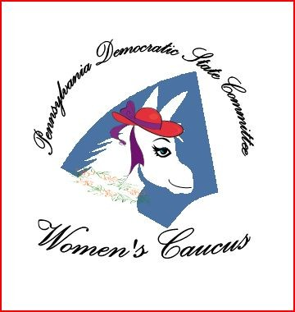
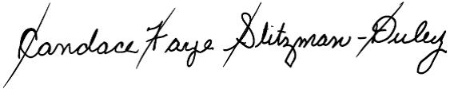
Candace Stitzman-Duley
Chair, Pennsylvania Democratic State Committee Women’s Caucus
Chair: Candace Stitzman-Duley ♦ Vice-Chair: Alexander Bryan Altierie ♦ Secretary: Brad Koplinski ♦ Treasurer: Joanne Tosti-Vasey ♦ PAC Treasurer: Christine Porter-Mitchell

1115 Showers Lane, Reading, PA 19605-1048 ♦ Tel: (610) 823-8744 ♦ Email: czarinacandace@msn.com

